VR technology Lab II Report

Name: Dazhi Li

RUID: 197007456

YouTube link: <https://youtu.be/NzrSbZUke5s>

1. Abstract

I choose option A in Lab2 which is designing a room by Blender. A room with 3 walls and a balcony is an idea comes from my own home. I know that there should be window in my designed home, but I choose a balcony instead. In manipulation areas, creating a balcony needs the same manipulation as creating a window. Here is a brief view of my Lab2 project:

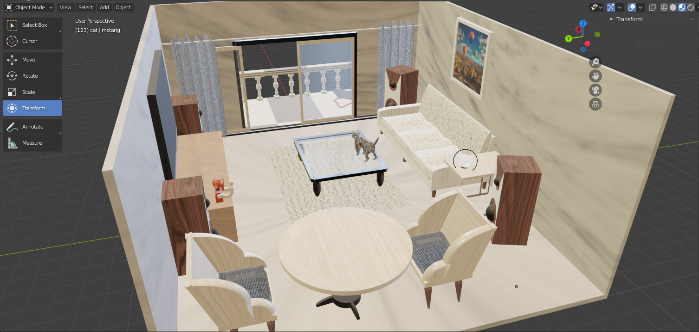

Figure 1

1. Required objects

In this lab we are required to have at least one window. Buy in my point of view, adding a window will not make our designed room look better. So as I mentioned above, I did a balcony and a curtain instead. As the figure 1 shows, there are three walls in my project. I was also considering adding a ceiling for my room. However, a ceiling will block our views to directly observe my design. There are more than 10 distinct furniture in my room. Let me show them sequentially.

1. Round table

It’s a quick made table with two cylinders. The bottom is made by a extrude individual and a bevel manipulation.

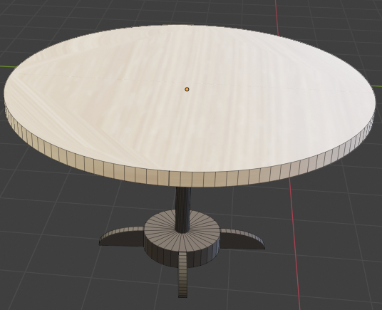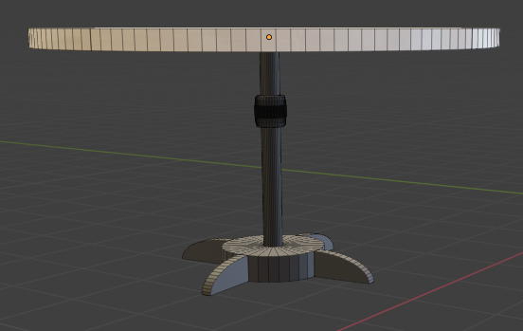

Figure 2-1

1. A balcony with columns and a beach chair on it. Column are made with main cylinder and two cubes on both bottom and head of it. Beach chair is made with multiple cubes to form the wood structure. Also a plane on it with cloth physical properties. A solidify modifier to make it thicker than a plane.

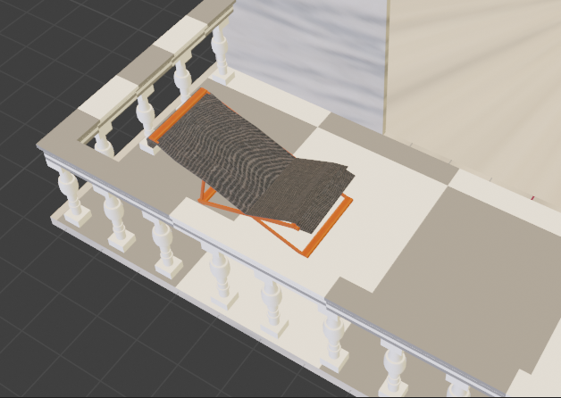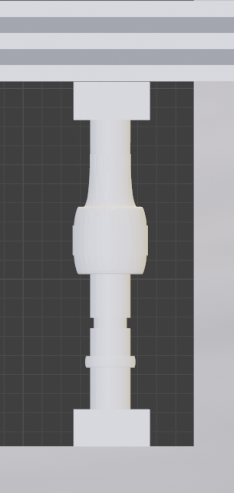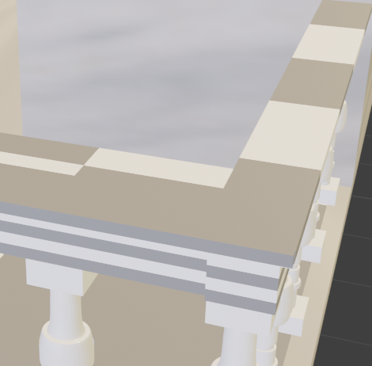

Figure 2-2

1. The transparent door modeling is very easy. The hardest part is making it transparent. Since Blender has no direct transparent value, I read Blender user manual to find we can modify the value of alpha to make it transparent. Also, we need to modify other parameters to make it looks like a glass in the door frame. Another thing to build a door is modeling a door track on the ground.

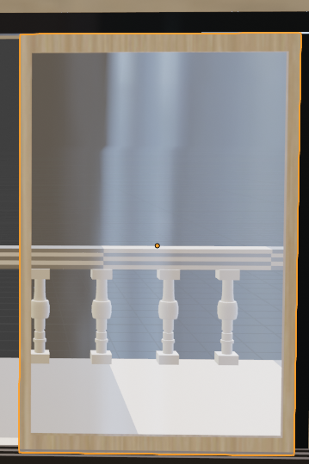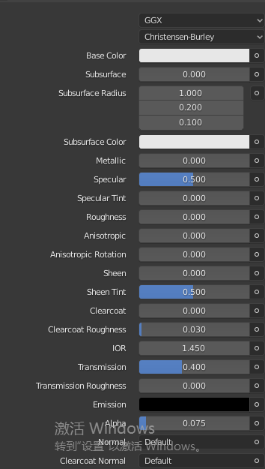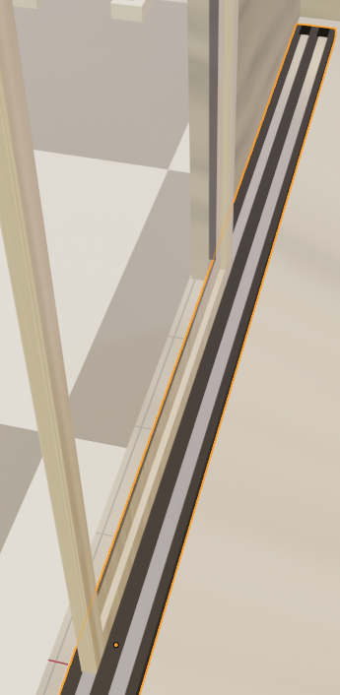

Figure 2-3

1. Television and television table with video player

Television is an easy part but television table we need some time to model it. Since every 3-D object made in Blender is empty inside, we need to fill face when we delete some faces. Those flashing lights on video player is made by circle to horizontally sculp on a cube. Then I use multiple materials on those flashing lights. There is also a cable to connect the television to the video player.

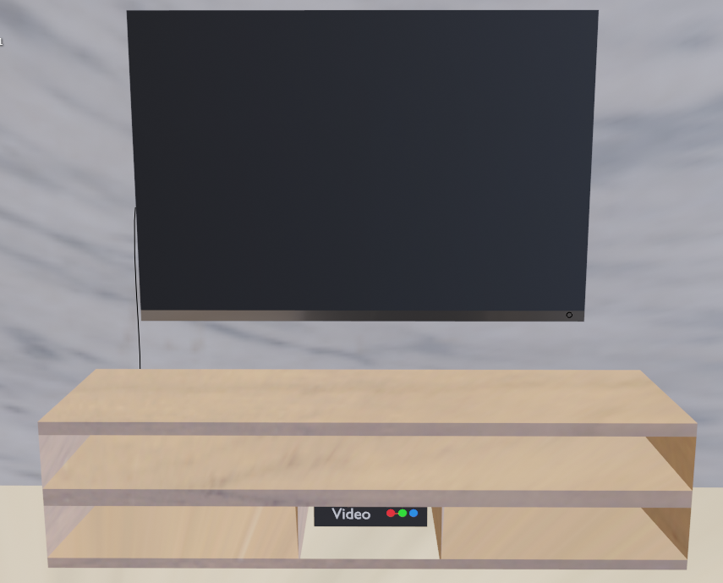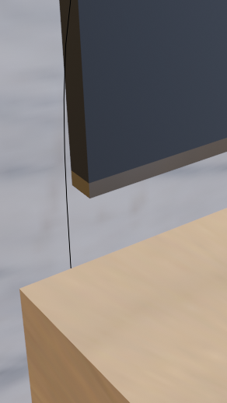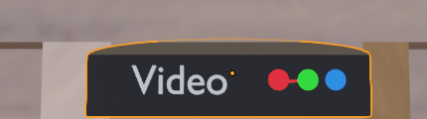

Figure 2-4

1. Sofa

Sofa is absolutely the hardest part in my project. Normally pillows are not just like cube, I need to do many modifications on it to make it a little bit curve in four sides of it. And choosing a suitable material to make it feel like comfortable.

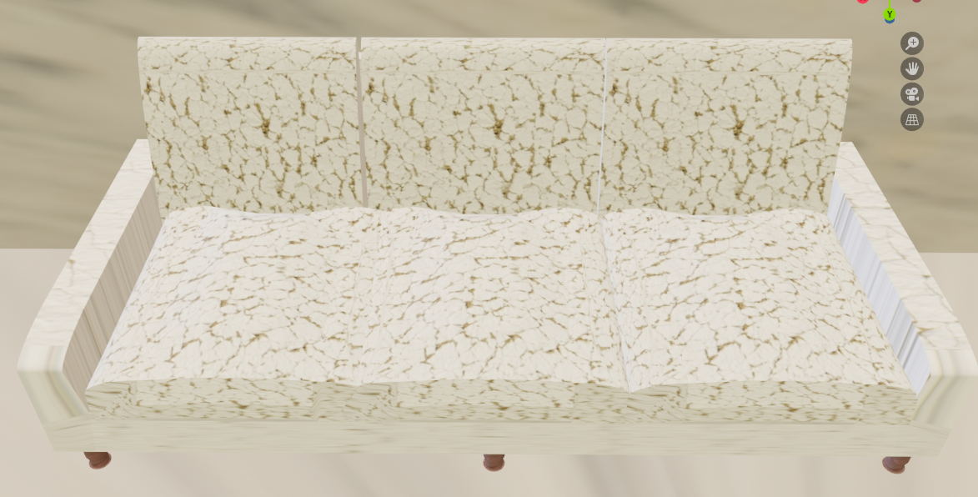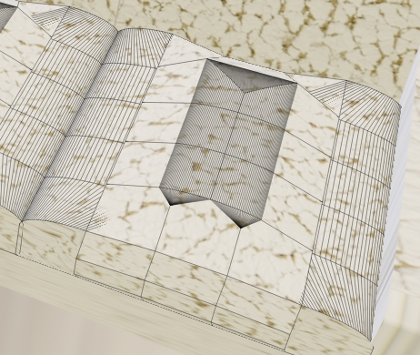

Figure 2-5

1. Carpet and transparent table

Since I have already modified a suitable material for transparent object. This part I only need to find suitable material for furs on carpet.

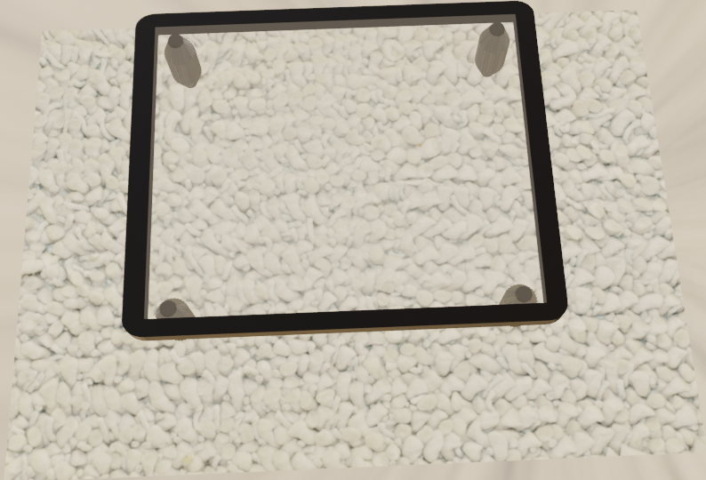

Figure 2-6

1. Mounted photo frame

The hardest point in this part is making the photo shown completely. Since Blender is just a tool which is not so smart that will automatically set those photos shown completely. I use shading modifier and add some nodes to adjust the photo size.

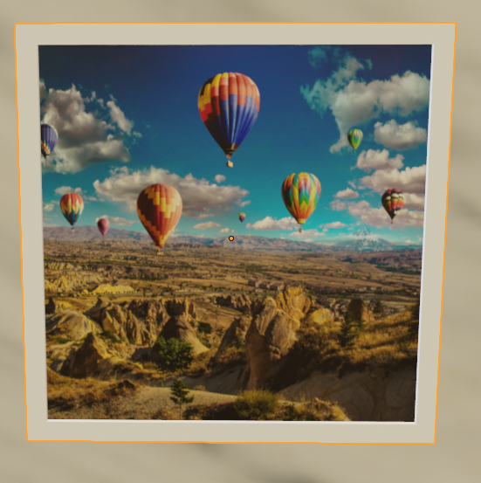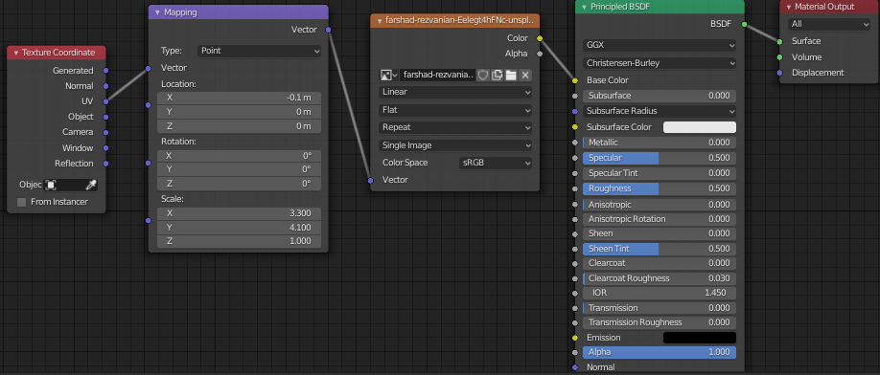

Figure 2-7

1. Speakers

Those speakers are easily made by bevel and other manipulations

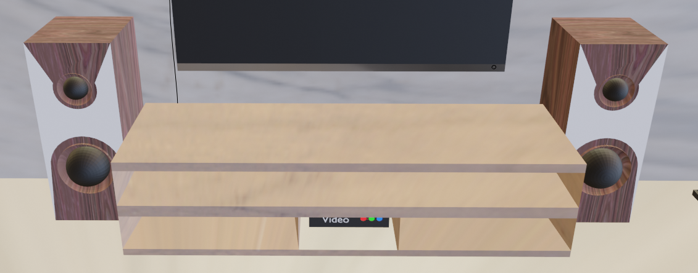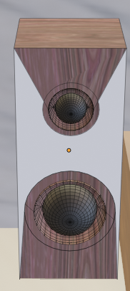

Figure 2-8

1. Chairs

Chairs are easily modeled with previous texture and pillow model. The only thing I need to do is making a chair model, mainly achieved by bevel.

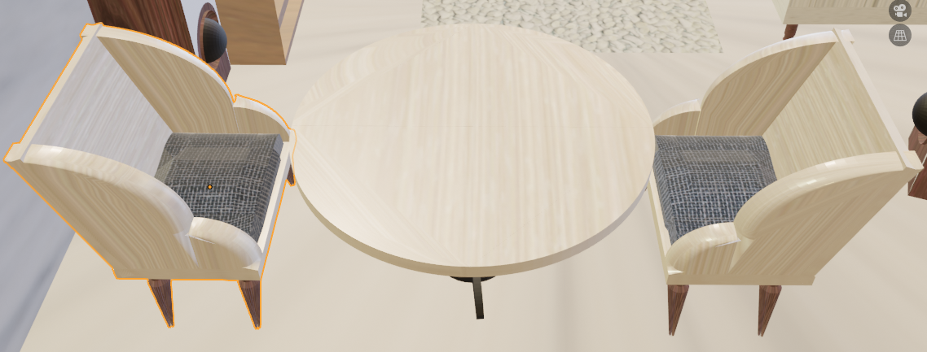

Figure 2-9

1. Curtains

Curtains is hardest part in this lab. I use a plane and multiple loop-cut it. Then I can make some angles on it. Also, I need cloth physical property on it and self-collision to make it looks more real. The curtain should set a bool modifier to the curtain rack to make the curtain rack directly go through it.

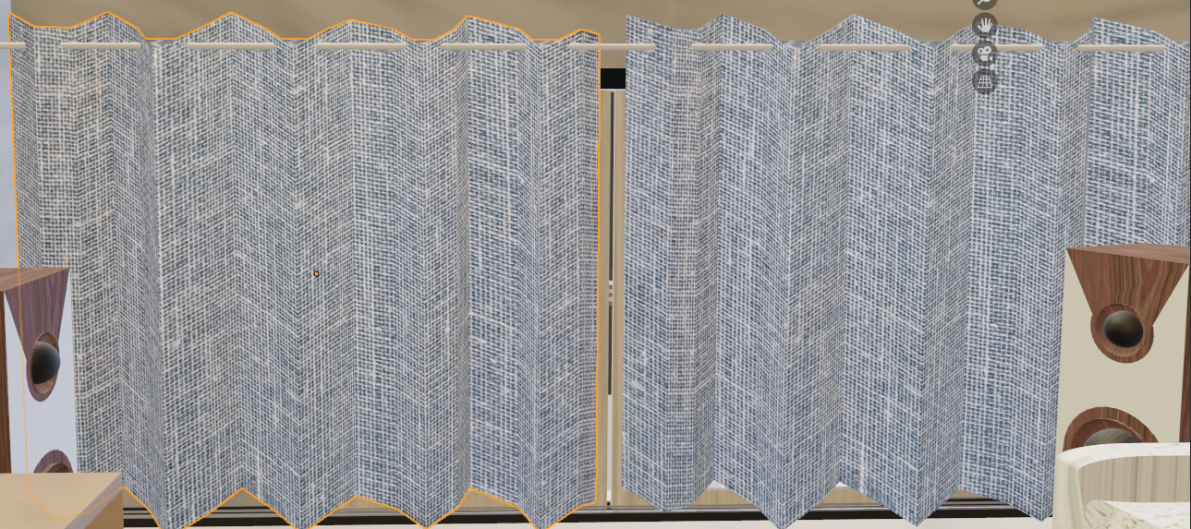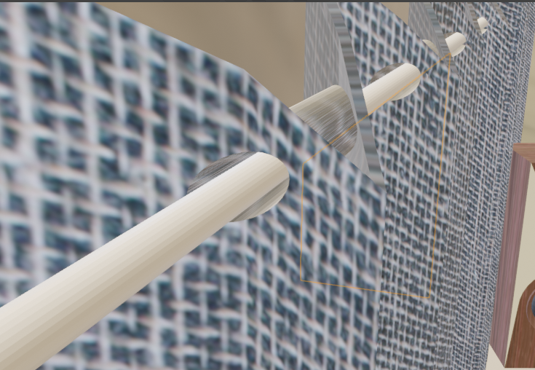

Figure 2-10

1. Light bulb and lights

Light bulb and table under it are easily made by modeling. The purpose is adding some lights to the room. I use point light to make it real but not so efficient to light the whole room.

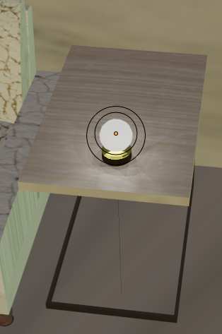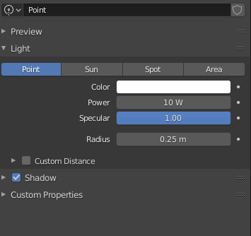

Figure 2-11

1. Monkey toy

I create a monkey mainly because I need to make another animation which is not so unusual. This toy is made with a monkey head model and a body made by myself.

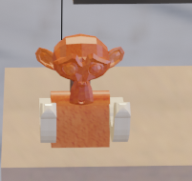

Figure 2-12

1. Animation

Non-armature-controlled animations

There are totally 3 kind of non-armature animations which is mainly shown in my YouTube video. The first kind of animation is converging the curtains, which is shown in **Figure 2-10**. The key frame utilizes the transforms and scale of curtains. The second animation is opening the balcony door, shown in **Figure 2-3**, which is achieved by transforms change. The third animation is dance monkey, shown in **Figure 2-12**. The little monkey toy will continuously shake his heads and move his hands, which is achieved by rotations.

Armature-controlled animations

I use a cat armature to be the parent set of the cat model, which allows me to do armature animation in pose mode. I observed how cat moves carefully to make the animation more real. The whole animation is, the cat will walk to the transparent table and then jump on it. As a matter of fact, there are a lot of key frames in my animation to set the right pose of the cat and the transform of it.

1. How to run my Blender project

There is a file named Lab2.mtl in my zip file. Use txt editor or other tools you like to open it. All the textures are set in one file name textures. You need to unzip the file and find the correct path to the texture file and change the path written in the mtl file.

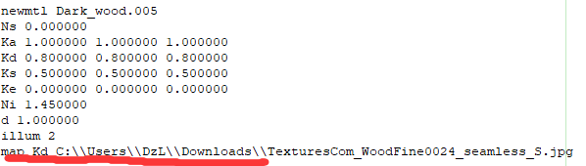

Figure 3

Like what I show in **Figure 3**, you need to change the red marked folder path to your own ones. Every texture file needs to change the path.

1. Conclusion:

Blender is a very useful software tool for us to do modeling mesh. The scene designed could be basically divided into 3 parts. The first part is how we model a mesh, a mesh which is more similar to a real object is better for user to immerse. Second part is the texture/material part. Finding suitable material for our mesh will make the whole scene seem like realism. The third part is, adding some animation or extra rendering to it. Animation is not necessary if we just want to make a fancy model, but animation is the key for user feels like the world is alive. Extra rendering in my comprehension is making things more real. For example, adding light source, changing the shading editor etc. Lab2 is really helpful in my further VR understanding to 3-D models and animations.